CONVOLUTION NERUAL NETWORK

In ANN,

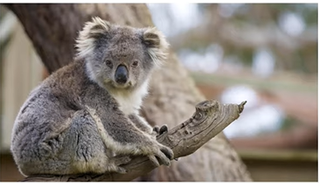

Image size = 1920X1080X3

Hence , we require first layer neuron = 1920 X 1080 X 3 = 6 mil

Hidden layer at least require = 6 mil

Weights between input and hidden layer will = 4 mil X 6 mil = 24 million

DISADVANTAGES OF ANN :

1. Too much computation
2. Sensitive to location of an object in a image

CNN:

*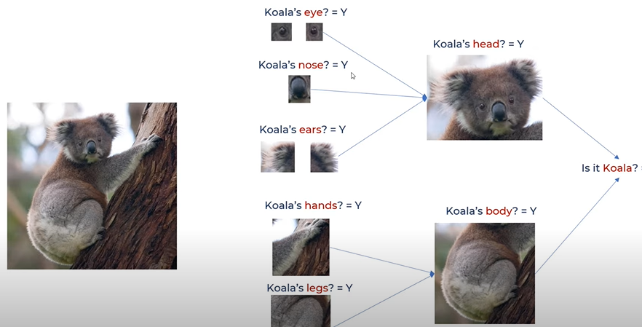*

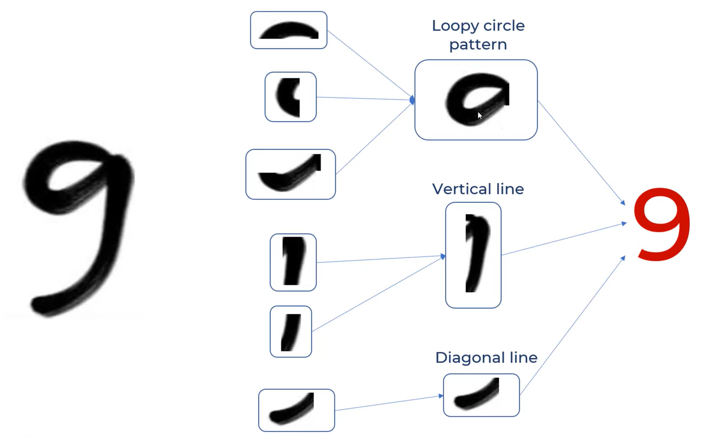

CNN use filters to recognise these patters. In case of ,the above image we have 3 filters

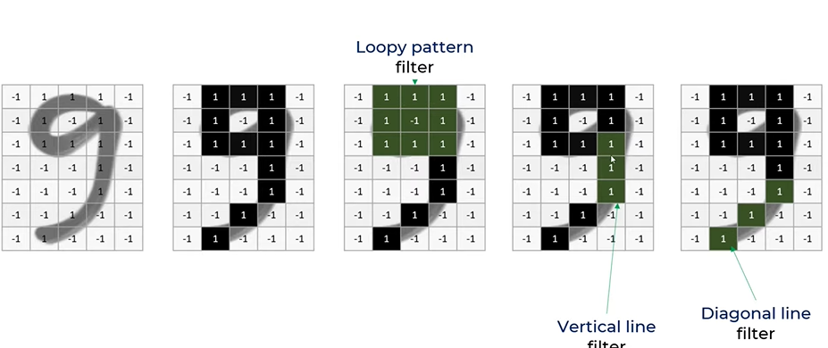

CNN perform filter operation , where each of these filter will be compared with the original image and if it matches the particular feature is mapped . hence filter are feature detector.

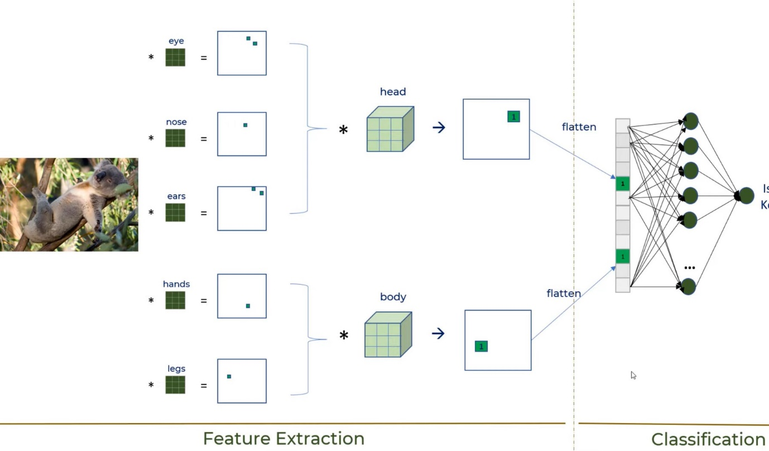

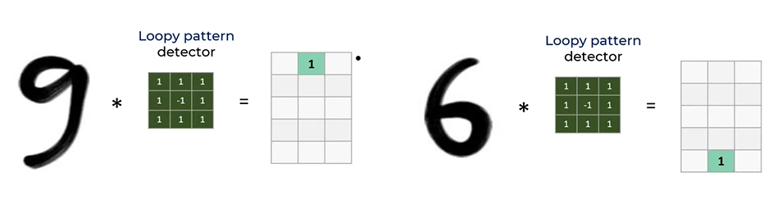There are two parts in CNN : feature extraction and classification.

ACTIAVTION FUNCTION

RELU(rectified linear unit)

convert negative value into 0 , if it is positive then leave it as such. Allows Non linear patterns(allow complex data).

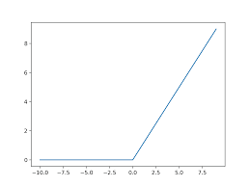

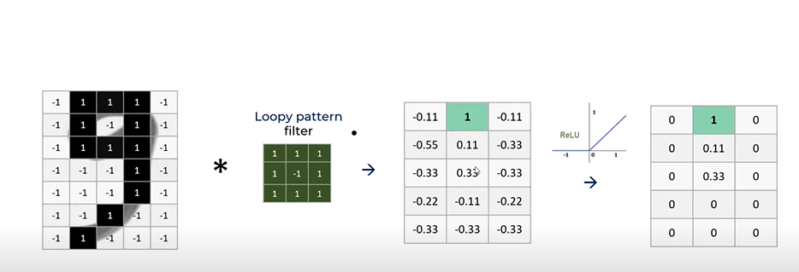

SIGMOID

Maps input value to value between 0 and 1 .

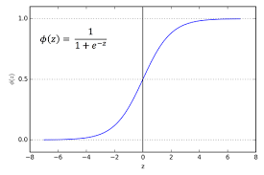

POOLING :

To reduce the size of the neural network we use pooling method . In image classifier we use maxpooling of size (2,20 and stride = 2)

